UiB NanoStructures Laboratory
Standard Operating Procedure
Plasmatherm 790+ Reactive-ion etcher

Purpose of the instrument:
The Plasmatherm 790+ reactive-ion etcher is used to selectively and an-isotropicly etch organic, metal, semi-conductor, or oxide thin-films. The main purpose is to transfer patterns in resist layers to other thin film layers without under-etching the mask layer.
Location of the instrument:
Allégaten 55, cleanroom in room 286 (entrance via 276, E-Beam lithography Lab)

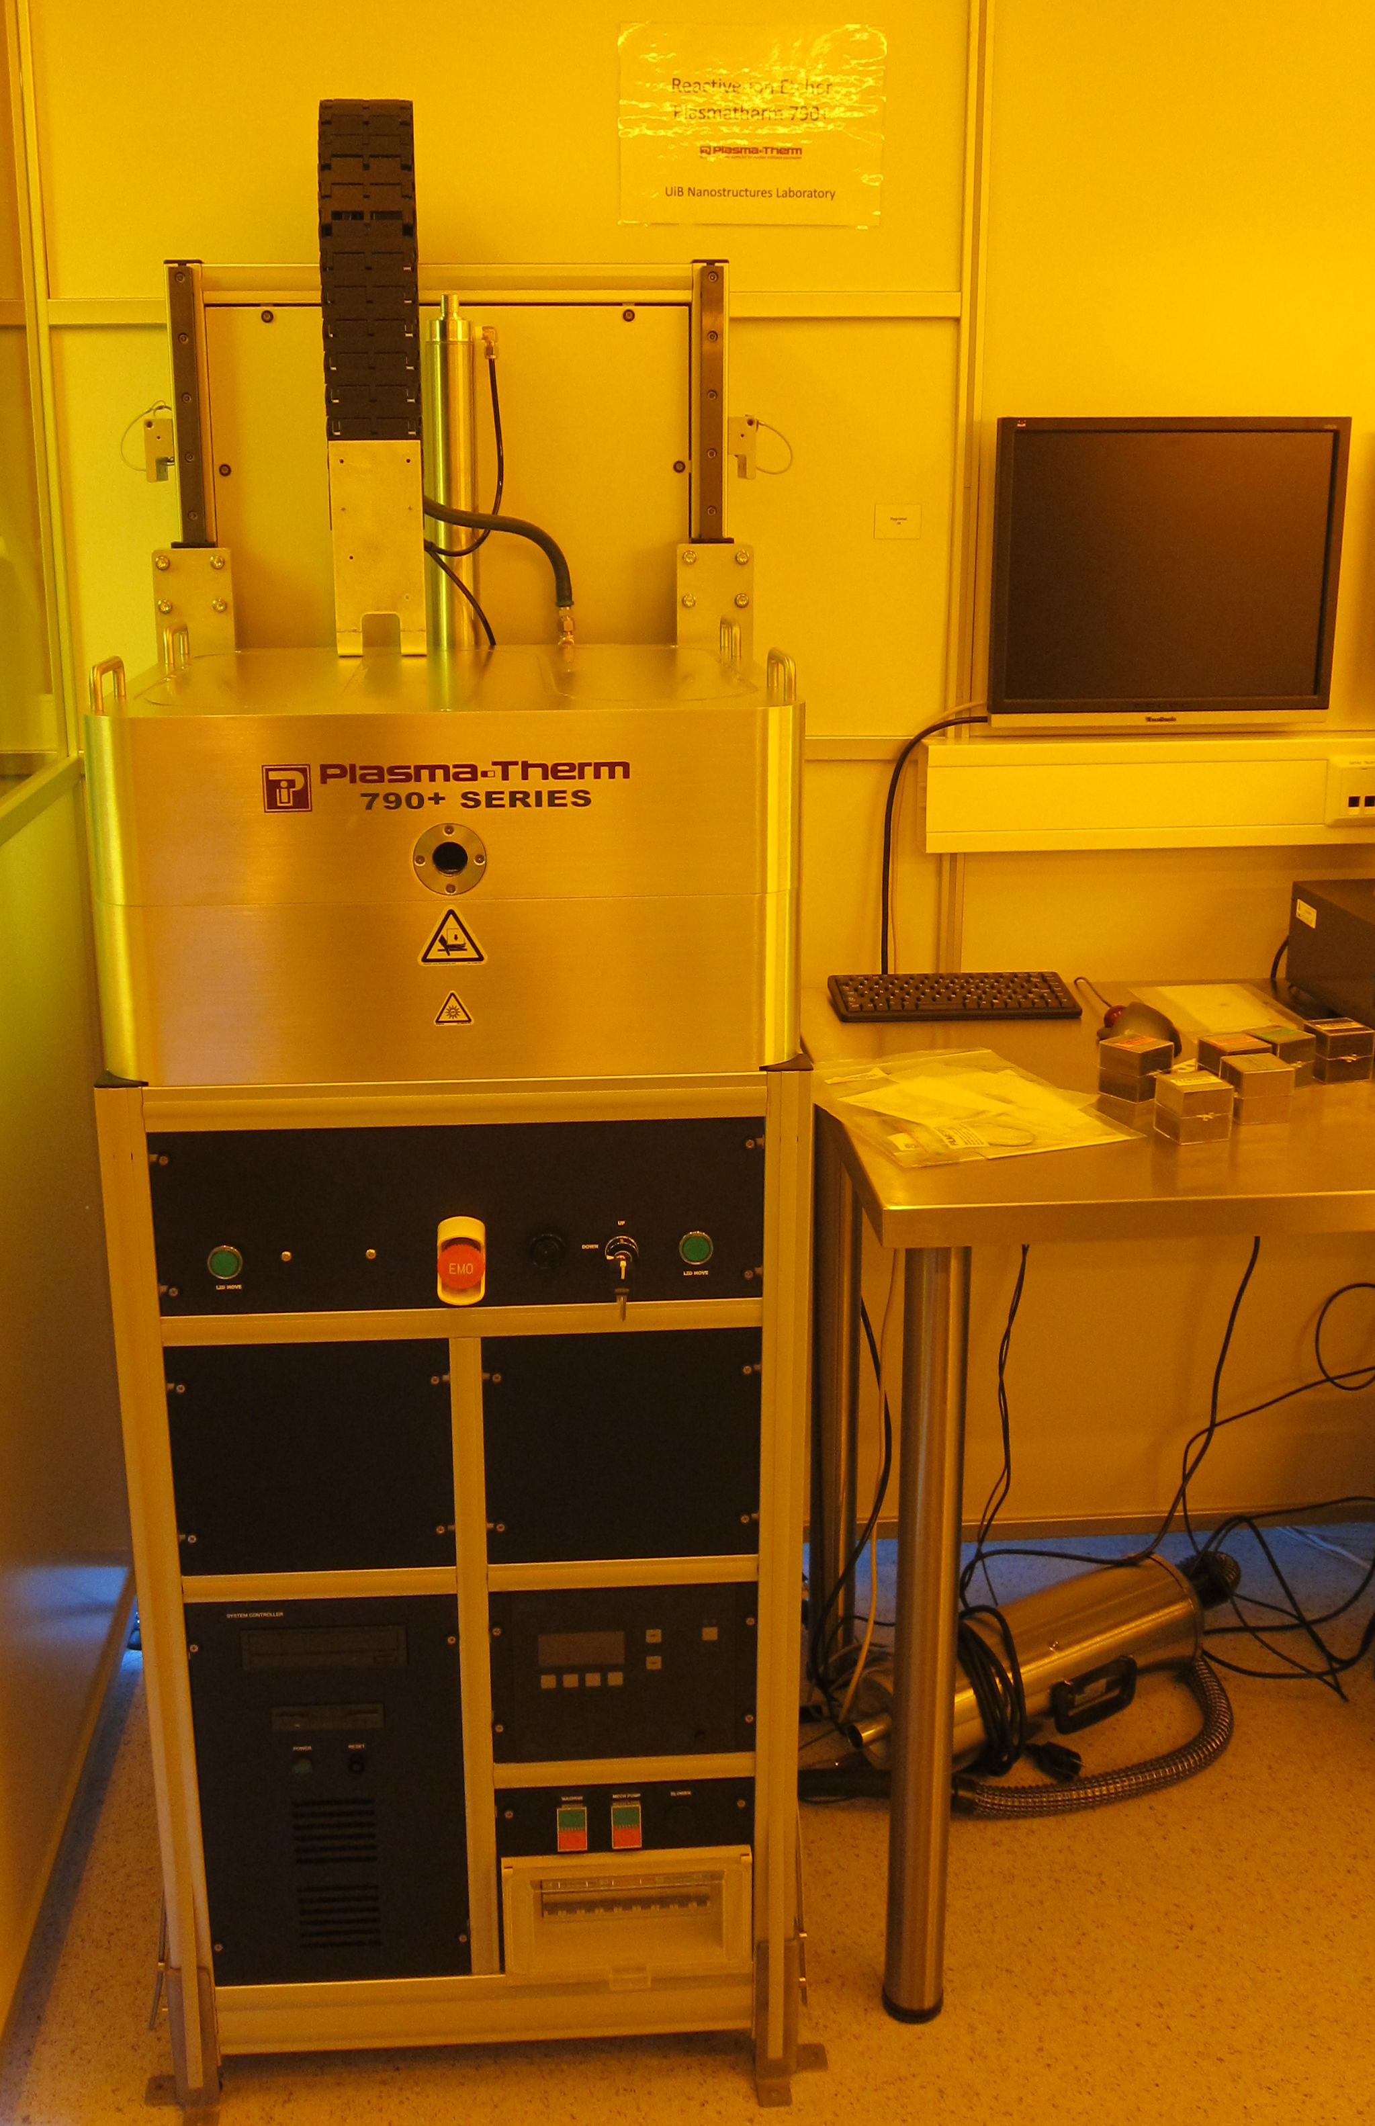
Primary Staff Contacts:
Erik Mannseth (Tel: 555-88326, Mob: 91626999,
E-mail: Erik.Mannseth@ift.uib.no)
Thomas Reisinger (Tel: 555-88326, Mob: 94784857,
E-mail: thomas.reisinger@ift.uib.no)
Xiaodong Guo (Tel: 555-88327, Mob:,
E-mail: Xiaodong.Guo@ift.uib.no)
Bodil Holst (Tel: 555-82967, Mob:,
E-mail: Bodil.Holst@ift.uib.no)

Service Contacts:
Steve Brown, Plasmatherm Europe Ltd (Ireland),
(Tel: +353-1-8216792, Mob.: +353-87-2698039,
E-mail: steve@plasmathermeurope.com)
Tech support: Email: techsupport@plasmatherm.com

Available etch gases:
CF4, CHF3, Argon, Helium, and Oxygen.

WARNINGS
The process gases themselves are not toxic, but the process products contain the very toxic substance HF, so be aware of this when the system is malfunctioning and that your sample may become toxic in the process. Other dangers include the UV emission from the viewport, squeezing your fingers with the chamber lid, hot surfaces and electric high-tension. Study the manual in detail.

The UiB NanoStructures Lab is operated for the benefit of all researchers. YOU MUST HAVE RECEIVED PERSONAL TRAINING ON THE INSTRUMENT TO BE PERMITTED TO OPERATE IT! IF YOU HAVE BEEN TRAINED AND ARE STILL UNCERTAIN AS TO HOW TO OPERATE THE INSTRUMENT CONTACT ONE OF THE STAFF MEMBERS. If you encounter any problems with this piece of equipment, please contact the staff member listed above immediately. There is never a penalty for asking questions. If the equipment is not behaving exactly the way it should, contact a staff member. This SOP only serves as a quick reference. For further details consult the manual and/or service engineers.
Basic Usage (Dry-etch sample with existing recipe)

- Please also refer to the manuals - they are available in printed form in the cleanroom.
- Check that the system is in stand-by mode and that the process chamber is being pumped with the turbo pump.

Figure 1: Venting the process chamber (Screenshot is not exactly like on our tool)

- Vent the system by selecting ‘Vent’ in the Utilities drop-down menu. Wait for the system to indicate ‘Atmosphere’ in the schematic (it turns from red to cyan). See figure 1.
- While the chamber is venting fill in the tool’s log sheet with the process details you are intending to run. If you encounter problems please note them on the back of the sheet and immediately contact one of the primary staff contacts.
- Make sure the key-switch at front of tool is set to ‘lift up’. Lift the process chamber lid by pressing the two LID MOVE buttons at the front of the tool that have turned green (figure 2). Lift the lid all the way.
Figure 2: Lid lift controls.

- Secure the Chamber lid.
Figure 3: Securing the chamber lid.
- Make sure that you are wearing cleanroom latex gloves and place your sample with tweezers into the process chamber and at the middle of the graphite plate.
- Unlock the chamber lid (see figure 3).
- Set the lid-controls to ‘Lift down’ and close the chamber by pressing the two LID MOVE buttons.
- In the utilities menu select ‘Pump chamber’ to evacuate the process chamber.
- Once the chamber is being pumped with the turbo pump, select Load in the Process drop-down menu.
- Select the file corresponding to the process you intend to run. Refer to the manual for information on how to edit processes.
- Press the ‘Ready’ button at the bottom left of the System Monitor software.
- Click on ‘Run’ at the bottom right of the System Monitor software. The Process starts - each recipe is usually made up of 4 steps:
  - Keep process chamber below pressure threshold and heat exchanger temperature at set point.
  - Flow gases at rates given in the recipe file and wait for flow (and other process parameters to stabilize)
  - Spark plasma and keep it running for the process time
  - Flush out process gases and wait until process chamber below pressure threshold.
- If you want to run one of the process steps for a shorter time than given in the recipe, you can click on ‘End Step’.
- After the process has successfully finished, an alarm will sound - click on ok to terminate it.
- In the Utilities menu select ‘Vent’. Wait for the system to indicate ‘Atmosphere’ in the schematic (it turns from red to cyan). See figure 1.
- Make sure the key-switch at front of tool is set to ‘lift up’. Lift the process chamber lid by pressing the two LID MOVE buttons at the front of the tool that have turned green (figure 2). Lift the lid all the way.
- Secure the Chamber lid (see figure 3).
- Make sure that you are wearing cleanroom latex gloves and remove your sample with tweezers from the process chamber.
- Unlock the chamber lid.
- Set the lid-controls to ‘Lift down’ and close the chamber by pressing the two LID MOVE buttons.
- In the utilities menu select ‘Pump chamber’ to evacuate the process chamber.
- Leave the system in Standby mode.

Document History

Version 0.1, 01-MAR-2012, Author: Thomas Reisinger, Changes: First version

