UiB NanoStructures Laboratory
Standard Operating Procedure
Filmetrics- F10-RT

Purpose of the instrument:
The Filmetrics F10-RT is used to measure the thickness of thin-films by analyzing the reflected and transmitted spectra from a white light source. This is useful both to determine the thickness of spin-coated resist layers or to calibrate the thickness of the metal thin-films deposited using the Temescal FC-2000.
Location of the instrument:
Allégaten 55, room 286 (entrance via 276, E-Beam lithography Lab)
Primary Staff Contacts:
Erik Mannseth (Tel: 555-88326, Mob: 91626999, E-mail: Erik.Mannseth@ift.uib.no)
Thomas Reisinger (Tel: 555-88326, Mob: 94784857, E-mail: thomas.reisinger@ift.uib.no)
Xiaodong Guo (Tel: 555-88327, Mob:, E-mail: Xiaodong.Guo@ift.uib.no)
Bodil Holst (Tel: 555-82967, Mob:, E-mail: Bodil.Holst@ift.uib.no)
Service Contacts:
Julia Hartmann (Tel: 49 8922061245, E-mail:hartmann@filmetrics.com)
Ber?

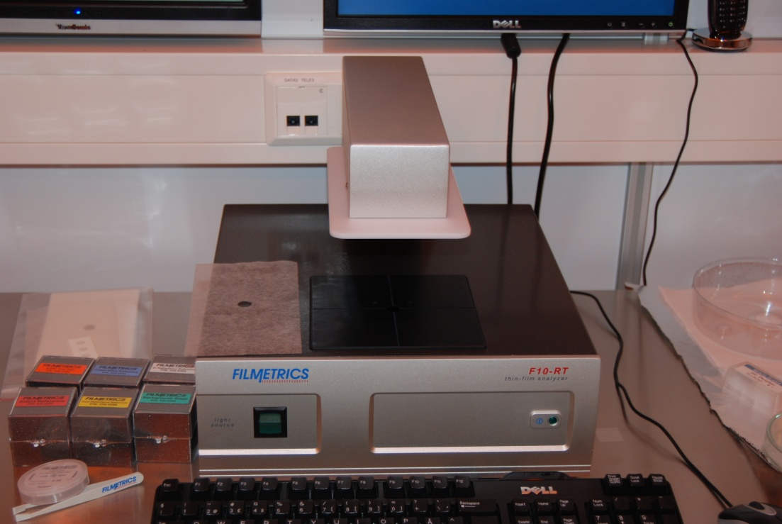
Figure 1: The tool
WARNINGS
- Shock Hazard – Do Not Enter
- Never expose the unit to water or liquids. Avoid direct sun.
- Do not insert any objects into the unit.
- Do not use near open flame or heat.
- The unit should never be enclosed or blocked.
Make sure you handle the samples with care as they could be coated with something potentially dangerous. Also be careful not to damage the sample when placing it on the tool for measurement.
The UiB NanoStructures Lab is operated for the benefit of all researchers. YOU MUST HAVE RECEIVED PERSONAL TRAINING ON THE INSTRUMENT TO BE PERMITTED TO OPERATE IT! IF YOU HAVE BEEN TRAINED AND ARE STILL UNCERTAIN AS TO HOW TO OPERATE THE INSTRUMENT CONTACT ONE OF THE STAFF MEMBERS. If you encounter any problems with this piece of equipment, please contact the staff member listed above immediately. There is never a penalty for asking questions. If the equipment is not behaving exactly the way it should, contact a staff member. This SOP only serves as a quick reference. For further details consult the manual and/or service engineers.
Basic Usage

- Turn on the tool with the button located at the backside of the tool (see Figure 1).
- Make sure the light source button (green button on the front) is on. The light source needs 30 minutes warm up time before it gives consistent results.
- Log into the Filmetrics software on the computer by pressing the FILMeasure icon on the desktop.
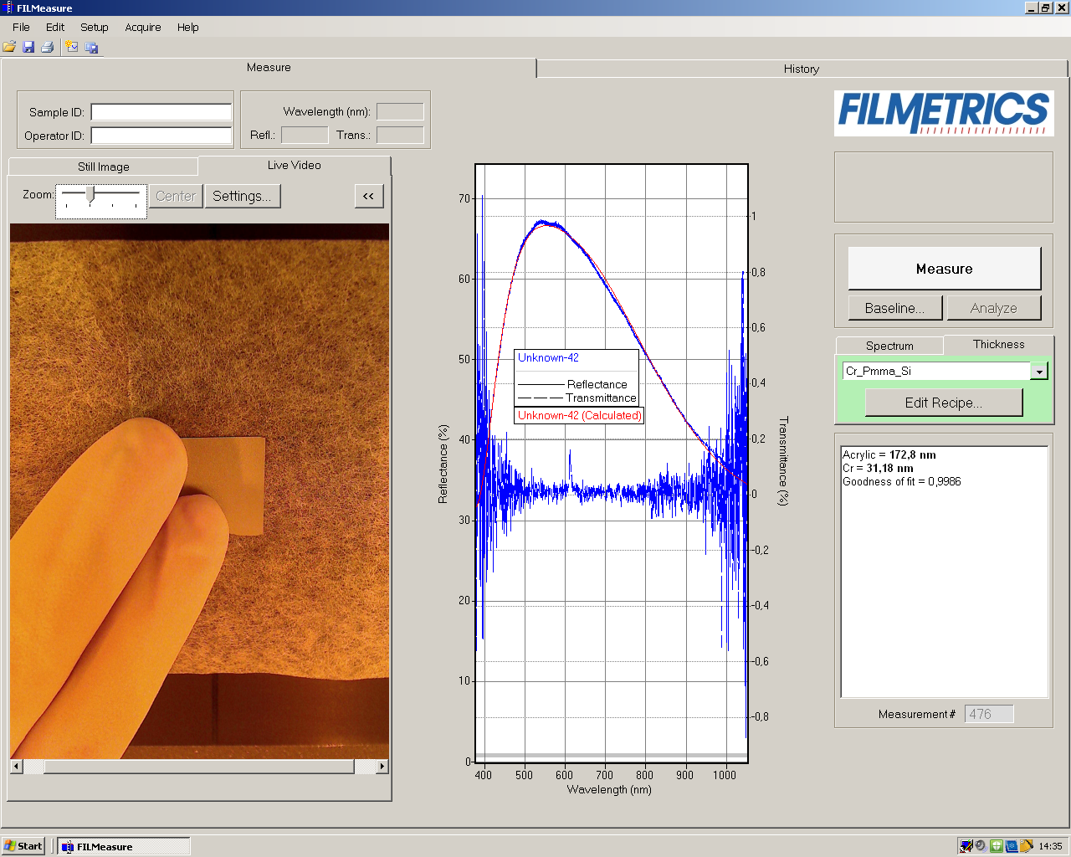
Figure 2: The Filmetrics user menu
- After waiting 30 minutes you can start the calibration. Press the Baseline button (see right side of Figure 2). This starts a process to calibrate the tool for your measurement.
- Place the wafer (sample) you want to measure onto the central platform, above the hole with the side you want to measure facing down (be careful that the sample does not fall into the hole).
- Follow the instructions of the baseline procedure, using the correct samples from the boxes (with names) placed besides the tool (se Figure 3). For silicon wafers use the Si reflectance reference, for glass wafers use fused Silica reference. For the other steps use the names given by the program.
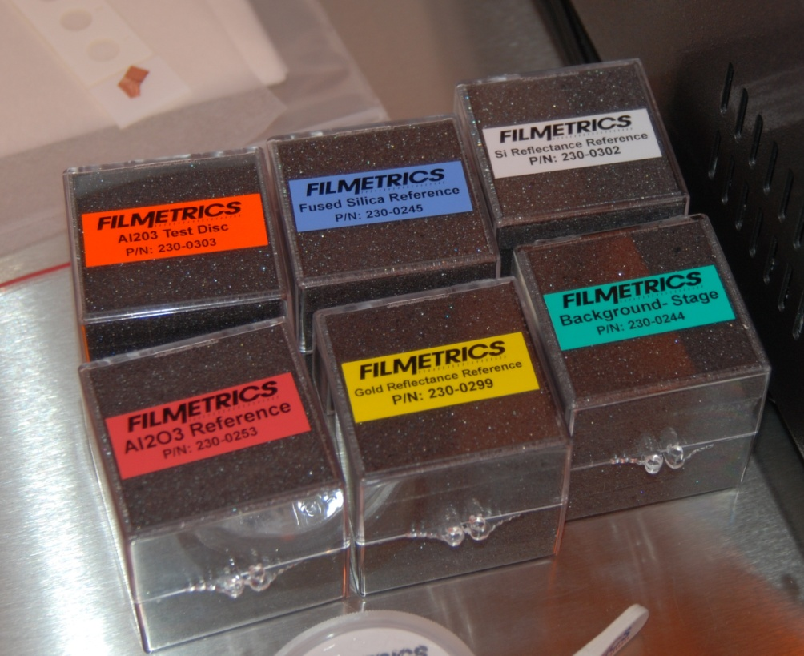
Figure 3 : The samples used for calibration

- Choose the “recipe” for the material you are measuring. If the layers of material you are using are not listed you need to create a new layer composition. Creating a new recipe is done by pressing edit recipe (see Figure 4).
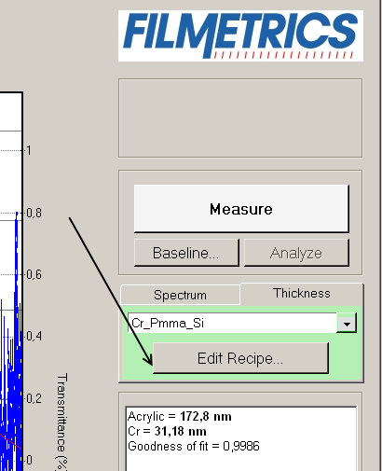
Figure 4: Edit recipe button

- If you are editing the recipe read this else jump to 9. When you press the edit recipe button you should see a dialogue like in Figure 5. Here you can add layers of a specific thickness in the correct order to describe your thin-film stack. You can also choose which materials the machine should try to measure, if you are sure about the thickness of some layers. This is done by checking the checkboxes in the vary column (if it is not checked the program assumes the given thickness is correct, if it is checked the given thickness is used as a reference value). Use the buttons on the left side to add or remove layers in the stack and the dropdown menu to choose the type of material.

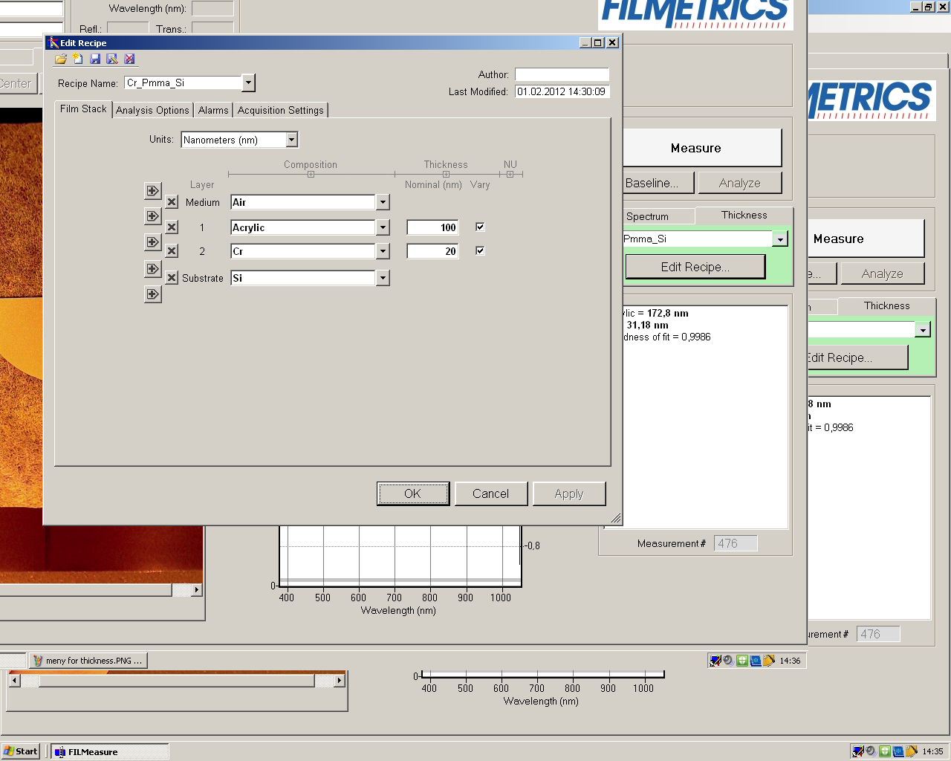
Figure 5: The recipe editing menu

- Place your sample back over the hole. Press the Measure button (see Figure 4).
- Look at results in the graph window; make sure to look at the transmittance or reflectance according to what you are doing. Check that the resulting graph looks similar to the reference. Look at the Godness of fit number (in the area below the edit recipe button); the closer it is to 1 the more accurate the result is.
- When you are finished using the tool turn off the light (front button), log of the software and turn of the tool with the power button at the back.

Document History

Version 0.1, Feb-2012, Author: Erik Mannseth

Version 0.2, Mar-2012, Author: Erik Mannseth, Thomas Reisinger

