UiB NanoStructures Laboratory
Standard Operating Procedure
Raith e-Line Electron-beam Lithography Tool

Purpose of the instrument:
The Raith e-Line can be used to expose a resist thin-film with flexible computer-generated patterns. The pattern in the resist layer can then be transferred to a different thin-film using a variety of processes also available at the UiB NanoStructures Lab (e.g. reactive-ion etching, lift-off, wet-etch, etc.). Maximum resolution is about 20nm half-pitch using PMMA as resist. Accuracy of interferometric stage to position sample is 1.5nm.
Location of the instrument:
Allégaten 55, room 276
Primary Staff Contacts:
Erik Mannseth (Tel: 555-88326, Mob: 91626999, E-mail: Erik.Mannseth@ift.uib.no)
Thomas Reisinger (Tel: 555-88326, Mob: 94784857, E-mail: thomas.reisinger@ift.uib.no)
Xiaodong Guo (Tel: 555-88327, Mob:, E-mail: Xiaodong.Guo@ift.uib.no)
Bodil Holst (Tel: 555-82967, Mob:, E-mail: Bodil.Holst@ift.uib.no)
Service Contacts:
Support Team, Dortmund (Germany), (Tel: +49 231 95004-499, E-mail: support@raith.de)
Application Scientist: Nikolas Damnik, (Tel: +49 231 95004-208, E-mail: damnik@raith.de)
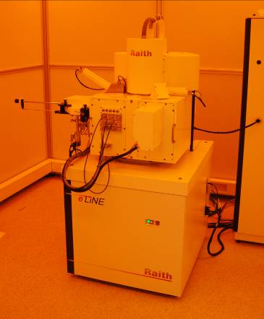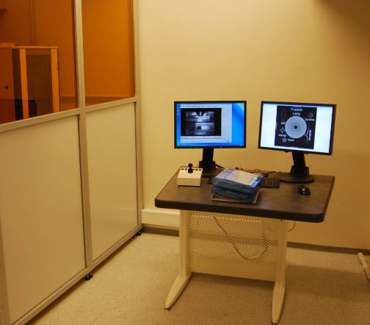

WARNINGS
The system produces X-rays, if the high-voltage is turned on. Do not remove any covers during operation! The system uses lethal high voltages up to 30 kV. Touching the power supply may result in death or serious injury. Do not change any system connections (especially the grounding!) Needless to say: Servicing of the column or high voltage system is restricted to Raith service engineers!

The UiB NanoStructures Lab is operated for the benefit of all researchers. YOU MUST HAVE RECEIVED PERSONAL TRAINING ON THE INSTRUMENT TO BE PERMITTED TO OPERATE IT! IF YOU HAVE BEEN TRAINED AND ARE STILL UNCERTAIN AS TO HOW TO OPERATE THE INSTRUMENT CONTACT ONE OF THE STAFF MEMBERS. If you encounter any problems with this piece of equipment, please contact the staff member listed above immediately. There is never a penalty for asking questions. If the equipment is not behaving exactly the way it should, contact a staff member. This SOP only serves as a quick reference. For further details consult the manual and/or service engineers.
Introduction: Basic overview of e-beam lithography steps

This is a brief overview of the steps required to create a patterned e-beam resist film. These steps are then explained in greater detail in the following sections. This document is only here to get you started. The documentation (E-Line Manuals) is available on both the E-Line computer and the computer next to it. To solve your patterning problems you may also refer to the primary staff contact or your e-Line colleagues. If you encounter an error you MUST contact the primary staff contact immediately (This is NOT optional!).

- Reserve time on the e-Line using the calendar on http://wikihost.uib.no/nanolab (Only time that you are actually using on the tool should be reserved!)
- Deposit a resist thin-film onto your sample. The resist is generally PMMA (Poly-methyl-methacrylate) and your sample maybe a piece of silicon wafer to begin with, both of which are available in the cleanroom. The deposition is achieved with spin-coater - refer to the spin-coater SOP. You should have your OWN resist bottle, tweezer, glass ware.
- Mount your sample on the e-Line sample holder. Put some Polystyrene beads at a corner of your sample for imaging. Make a sketch of where you placed your sample on the holder, its orientation and the place of the beads! DO NOT LOAD WET OR DIRTY SAMPLES INTO THE E-LINE!
- At the operator station, turn on the two screens and turn on the mouse (switch batteries if necessary).
- Make sure no one else is using the tool, or that it is still exposing - else contact the person in the previous entry of the log sheet.
- Fill in the User log sheet, record chamber and gun vacuum pressures! (NOT OPTIONAL!)
- Load the sample into the e-Line using the Load-lock procedure.
- Turn on High Voltage (EHT); 10keV is usually a good start. For thicker resists and also higher resolution you may want to use 30keV.
- Choose the aperture you want to use for your write (Depends on many different process parameters, such as resist, your pattern, required dose, etc. - start with the standard 30µm aperture)
- Drive the stage to z=25mm. This ensures that your sample is in focus at a working distance of about 10mm, and that you do not crash into the final lens (MUST BE AVOIDED AT ALL COST!) for thin flat samples at least.
- Use the wafermap in the e-Line software to locate your sample, making sure you are not exactly at the center where you will want to pattern. (CTRL + right click)
- Switch the detector signal from TV to InLens or SE2 (the latter if your EHT>22kV) in the Raith EO (SEM ZEISS LEO) software. Zoom out all the way (Magnification) and set the Working distance to 10mm. Unblank the beam in the Raith e-Line software. (The system has TWO beam blankers!)
- Find the beads using the joystick (Turn on using X and Y buttons on joystick), zoom in adjusting the working distance until you are in focus at about 50kX magnification. Adjust Aperture alignment with focus wobble, stigmation in X and Y, as well as working distance iteratively. Ensure you get a good image at 100kX magnification. Record vibration at even higher magnification. Test spot size and shape using the Spot mode. Make sure you do not change the working distance significantly after this.
- If you only want to image your sample, do the imaging now and then skip to point …
- Set the bead location where you focused to have U,V coordinates (0,0)
- Measure the beam current by moving the stage to the Faraday cup location and registering it in the e-Line software (and log sheet!!). Then return the stage to the beads on your sample (U,V = 0,0).
- Choose a write-field size (depending on your pattern, 100µm is standard) and perform the associated Align-write-field procedures by dragging them into a position list from the scan manager (usually 3 manual and 2 automatic with images). Check using the protocol tool that the Transformation parameters (zoom,shift,rotation) changed by not much more than ‘3’ in the final precision digit. If you want to use the Fixed-beam-moving stage mode (defined in your pattern file), you also have to do the very similar Beam-tracking alignment procedures.
- Open your pattern file/Create the pattern you want to expose. Prepare your file using the Raith e-Line software on the Client computer next to the e-Line workstation.
- If you want to align your pattern to already existing structures on your sample, then you should perform for example a three-point U,V adjust now. (Drive to point using SEM, select point in pattern file, click adjust - for all three points). Otherwise the Origin-Adjust should be enough to choose a good location on your sample.
- Calculate the correct dwell-times in the ‘Patterning Parameter Calculation’ window based on the measured beam current, the chosen dose (depends on resist, sample, development procedure, etc - 200 µC/cm^2 or 200pC/cm are a good start) and a step-size (2nm is the minimum in a 100µm writefield - i.e. the highest resolution your pattern can be - if you want faster patterning, choose a larger step size). Make sure you’re the coordinates in your pattern file are multiples of this step size - which will avoid pattern errors due to the software having trouble to interpret your pattern. In general, making it as easy as possible for the e-Line software to understand your pattern is a wise idea! Make sure the beam speed is below 10mm/second (1mm/second stage-speed for the fixed-beam-moving stage mode) or do not complain if your patterns do not come out right. To optimize the dose your first write should consist of a dose matrix (for this you only expose a small part of your pattern multiple times with different dose factors - such a write should not take more than 30 minutes, else you are wasting valuable time)
- Drag your pattern from the database file into a positionlist. Choose the position of your pattern on the wafer: The U,V coordinates will give the position of the lower-left writefield center of your pattern file (unless you change the working area settings). Note this position down so you can find your pattern again! In the extended properties settings of the positionlist-entry use the ‘times’ button to get a prediction of how long your write will take (this is only an estimate). If your write takes longer than 4 hours you should start using the tool at 5pm and let it expose over night.
- For a dose matrix, set the dose factor to the lowest dose you want to use - for example 0.5. The use matrix copy to create a dose matrix usually up to 2.0 times the dose set in the Parameter calculation.
- Once all the patterns you want to expose are in the position list, also drag the ShutdownBeam.js procedure at the end of the list, with a U,V position that is located a little beside your sample. This shuts down the high voltage at the end of the write. Select all the positionlist entries you want to execute using CTRL or shift, then right-click and choose ‘Scan’. On the pattern generator check the LEDs indicate the moving beam.
- Switch of screens, mouse and joystick during exposure.
- Turn of the HV if it is not already off. Unload the sample using the load-lock procedure once the exposure has finished - note down exposure times for your future reference.
- Develop the sample in the cleanroom by dipping it for 2 minutes in the Allresist developer for PMMA - a mixture between MIBK and Iso-propanol. Stop the development by rinsing it with or dipping it into Isopropanol. Blow-dry the sample with the nitrogen gun. If your pattern needs to be very precise you need to also keep temperature and development time/developer concentration constant!
- Re-load the sample into the e-Line to investigate your exposure. You may want to coat it with the sputter coater to get better contrast (PMMA alone does not image so well).
- If the pattern is as required proceed to the pattern transfer process of your choice!
Mounting your sample on the sample holder

There are a few things to remember when mounting your sample:
- NEVER touch the sample holder without gloves, since that leaves behind finger prints that worsen the vacuum! That means, first of all put on gloves! This also helps to avoid contaminating your sample with particles.
- Your sample must be DRY! Ask before mounting unusual samples. Certain materials can permanently worsen the vacuum inside the chamber or deposit on the mirrors of the interferometer, which may result in very expensive repairs!
- Never touch the pivot points (see figure 1). They are calibrated so that the sample holder will fall into the same position inside the chamber every time to within a few micrometers.

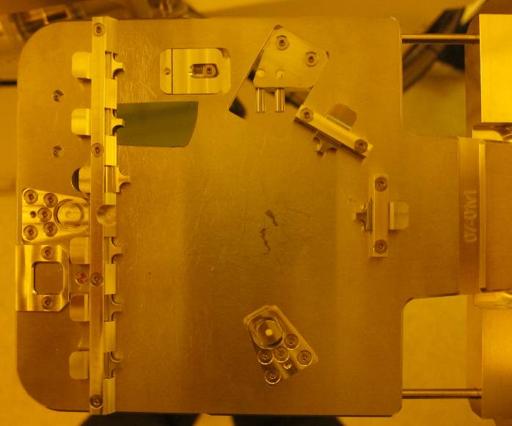
6x small samples
2x stub mount
Pivot points
- do not touch!
45° mount
2“ wafer
Figure 1: Sample holder for small samples and 2” wafers

- There are two sample holders. One for small samples with a variety of places to mount your sample and a separate one for full 4” wafers. There is a 45° mount to image wafer edges more clearly (use allan-key to fix mount). There are also two stub mounts to attach samples with sticky graphite pad (see starter kit), also fixable with allan-key from edge of sample holder.
- Insulating samples charge up and result in poor imaging and unpredictable patterning results. If necessary you can use the Temescal FC-2000 to deposit a thin aluminum film (a few nm) on top of the resist film. This is then removed using the aluminum etchant before the development step. If you just want to image and do not care for your sample afterwards you can also use the sputter coater next to the e-Line to deposit a thin Gold-Palladium film (see SOP for sputter coater).
- If you continue to have problems with charging you should consider that a thin film on top of PMMA is very fragile and possibly not well contacted with the sharp ends of the clips of the small-sample mounts. One remedy is to use a for example a piece of aluminum foil in between clip and sample to increase contact area.
- Try to align your sample with the sides of the sample holder as much as possible, since this will simplify your alignment tasks and finding patterns on your sample.
- Deposit some 100nm Polystyrene beads onto your sample, at a corner that will not be used in the patterning process (will be used for focusing the e-beam). Again, use the same corner every time and your life will be easier.
- Make a sketch of your sample on the sample holder, showing its place on the holder and the position of the beads.
- Be careful when placing the sample holder on the transfer rod of the load lock. Make sure it matches on the right with the inset and also sits horizontally. You can severely damage the final lens or the interferometric stage if the sample falls off inside the chamber due to improper placement on the transfer rod!

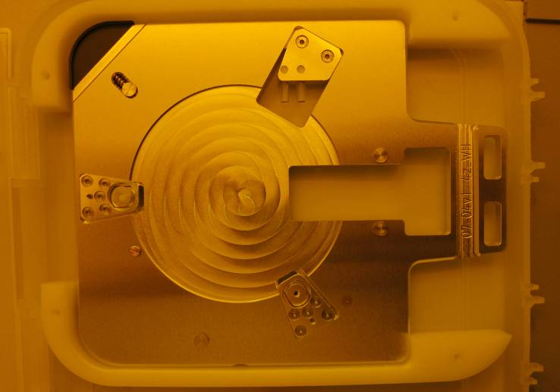
Figure 2: Sample holder for 4” wafers.
Software Overview

There are three important pieces of software installed on the e-Line terminal:
- SmartSEM or RaithEO software that controls the SEM column hardware and vacuum systems. Essentially a front-end to the hardware server that automatically starts up with the software. (Usually on left-hand screen)
- Raith e-Line software that controls lithography additions to the Zeiss Gemini SEM Column (such as the pattern generator, additional beam blanker, lithography stage etc). But in principle can do everything that the SmartSEM software is capable of. (Usually on right-hand screen)
- Raith Protocol tool that keeps track of procedures performed with the Raith e-Line software (such as aligning writefields or patterning steps etc). This is a last resort - you should always record your own process parameters yourself instead of digging in the archive all the time!
Shortcuts to different
scan speeds
Pause Scanning
Reduced scan-window size
Save tif file
Burn spot to evaluate focus spot size

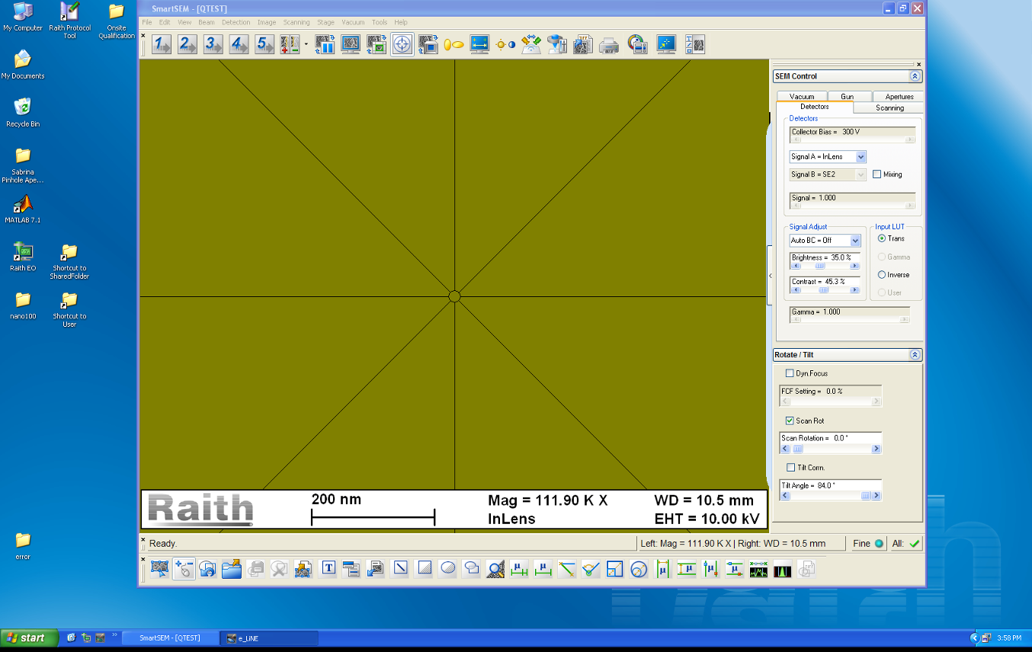
SEM column, vacuum control
Start SmartSEM
Shared Folder
User folders
For error screenshots
SmartSEM software
Cross Hair
Brightness/
Contrast
Magnification/
Working Distance
Image data-area
Figure 3 Left-hand screen of e-Line terminal running SmartSEM software.

The SmartSEM software should always be running. (It is started with the Raith EO icon on the desktop - see figure 3). If for some reason somebody logged off, you can log on with the username ‘qtest’. No password is set.

There are a few useful links on the desktop (do NOT delete them or hide them! - in fact do not change anything on the computer - keep files only within your own folder structure, which can be accessed via the ‘user folders’ link on the desktop. You are not authorized to install additional software on this machine!!! If you need additional software for your project to run in parallel with the e-Line software, discuss with the primary staff contact first! Matlab is installed on this machine, which is why it is connected to the university network via the client workstation. Do not use this computer to surf the internet or check your e-mail!

There is a shortcut to a shared folder on the desktop that is mounted also on the client workstation next to the e-Line terminal. Use this to exchange data between the two computers. The client workstation has a common log-on username: aspnet with password: NanoUser2011 Please do not log on with your own username because you will forgot to log off, which is annoying for the next person.

If you encounter an error please do contact a primary staff contact about it immediately, but also take a screen shot of the error message and safe it in the error folder on the desktop!

The most important functions of the SmartSEM software are marked in figure 3.

The Raith e-Line software gives access to the functionality that is specific to e-beam lithography. If you only have to do imaging you can just use the SmartSEM software. But Loading/Unloading (see next section) should be done using the e-Line software.

Figure 4 shows the basic functionality of the Raith e-Line software. Of course there is much more, but this should point you to the important parts.
Hardware Control Toggle between SmartSEM and e-Line software
Lithography Menus

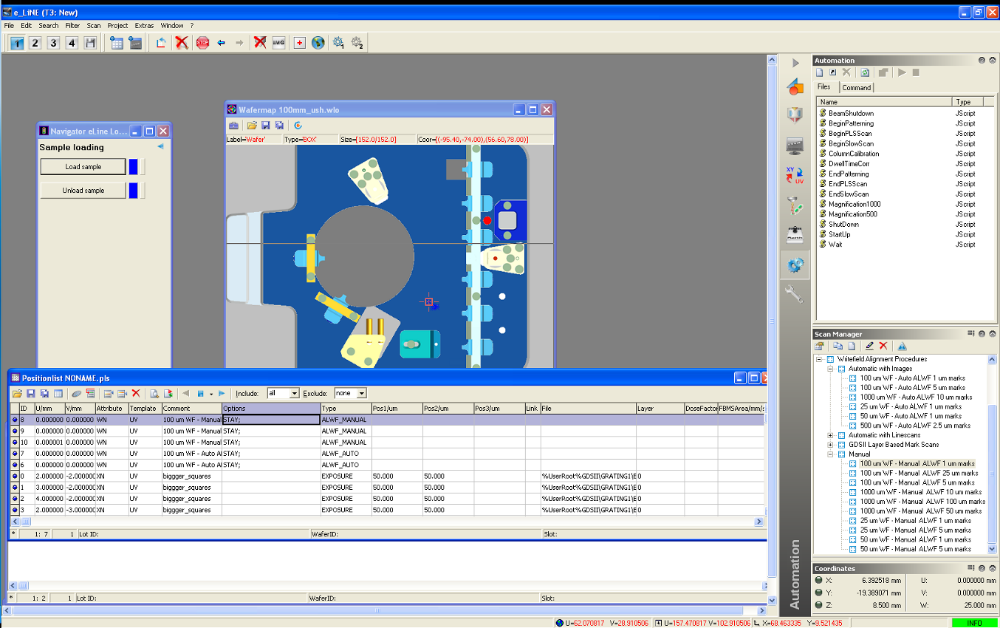
Wafer map
Access different desktops
Litho Beam Blanker
Sample loading
dialogue
Error messages show up in red here!
Figure 4: Right-hand screen of e-Line terminal running Raith e-Line software.
Loading the sample holder via the load-lock
- Make sure you have mounted your sample on the sample holder and placed it on the transfer rod of the opened load-lock. Also make sure that the second sample holder is not already inside the e-Line chamber (see TV-mode of the SEM software)
- Before you start the load procedure, check that the nitrogen gas-line is pressurized to 0.3 bar:
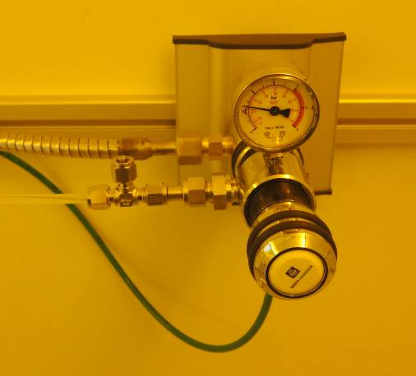
Figure 5: N2 pressure regulator for e-Line vacuum chamber vent.
- Fill in the log-sheet on the terminal desk! Also note down the vacuum pressures into the e-Line log-sheet, as shown in the gun and system vacuum indicators in the SmartSEM software under the ‘Vacuum’ tab:
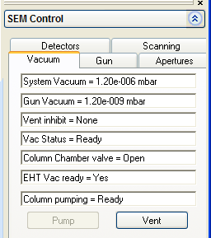

- To initiate the load procedure, go to the "Sample loading" screen, available via the left-most cog-wheel icon in the menu bar of the Raith e-Line software (see figure 4):
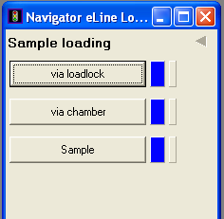
- Select "via loadlock" and then "Load Sample". Confirm the dialouge asking you if you wish to proceed. After this you will need to follow the instructions carefully:
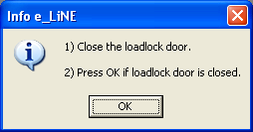

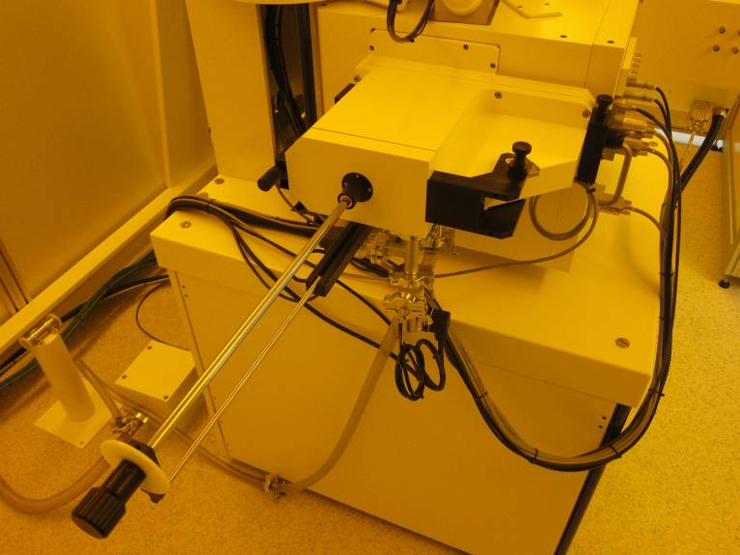
Transfer rod
Load-lock
Load-lock door
Load-lock
door-knob
Load-lock-valve knob
Load-lock-valve release
Figure 6: E-Line Load-lock
- Check that the load-lock door-knob is tightly closed, pressing the load-lock door against the load-lock. Then press ok. After the load-lock was evacuated with the dry-pump you should see the following message. If the load-lock door was not fully closed the it will not be able to evacuate the load-lock - so check if this part takes longer than a minute.
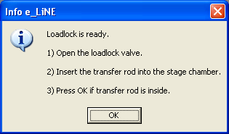
- To open the loadlock valve, lift the load-lock valve release, then turn the load-lock valve knob counter-clockwise. Then you can let go of the release and pull out the load-lock-valve knob. Make sure it’s pulled all the way out. Then slowly and carefully insert the transfer-rod (all-the-way!). If you do this with too much speed the sample holder can fall off inside the chamber, which will make a lot of people very unhappy!
- Once you have pressed ok, the stage will drive up and lift up the sample holder from the transfer rod. Once this has happened (it takes a few minutes) you should see the following dialogue:
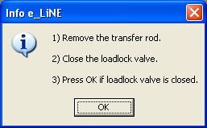
- Again, carefully!, pull out the transfer rod and close the load lock valve (push in load-lock-valve knob, turn it clock-wise until it has snapped into place. When the loading-proces is complete, the program will make two enquiries:
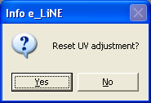
- If you have mounted the sample in exactly the same way as last time, then you can keep your UV adjustment. Otherwise it makes sense to reset it.
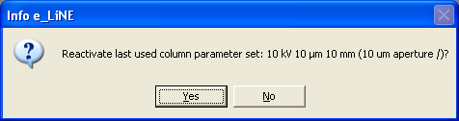
- This is a quick and automatic way to reset the parameters of SEM column. Unless the parameters mentioned in the dialogue are the ones you are going to use, choose no. If you have set up the column the way you need it for your sample later, it is possible to save these parameters and load them using the second lithography menu (figure 4).

Setup SEM column to do imaging/lithography

- After finishing the load procedure drive the stage to a position so that the electron beam just misses your sample. This way you avoid exposing it when turning on the acceleration voltage.
- Drive the stage to z=25mm, which corresponds to approximately 10mm working distance (this is the distance between final lens and sample. If you are using samples that are thicker than normal wafers (about 0.5mm) you must drive to a lower z position (i.e. less than 25mm) to keep enough distance between sample and final lens. DO NOT LOAD SAMPLES HIGHER THAN 15MM! Control the z-position using the Command Line in the Stage Control tab (see fig. 7). You could also use the ‘Drive’ tab and by setting the base to XY. But it is better to keep them in UV-mode since this is the only operation you will do in the XYZ coordinate-system and it will does prevent you from getting confused. Once you have typed the ‘z’ into the command line it already starts to move the stage.

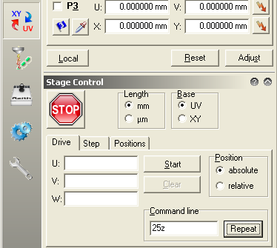
Figure 7: Stage Control

- Sometimes it may be necessary to work at smaller working distances to achieve a better signal-to-noise ratio for imaging. For samples with wafer thickness the software-limits of the stage should prevent you from driving into the final lens. However, a lot of care should be taken when doing this, and this should be always supervised using TV-mode! Note the STOP button in figure 7, which you can use to stop the stage movement at any time.
- Check that the system vacuum is below 2e-5mbar and that the gun vacuum is below 5e-9 mbar. See figure 8.

Figure 8: Vacuum tab.

- Move the stage so that the beam is pointed at a place on the sample holder adjacent to your sample. You do not want to hit your sample in the middle when you first expose it to the electron-beam. For this you can use the wafer map in the e-Line Software to navigate the sample holder. See figure 9. The green square is where the gun is currently at. By holding down the CTRL-button and right-clicking on the map will place that point of the sample holder underneath the column. If you cannot find the wafermap: it can be opened via the File menu in the e-line software. (Open wafermap -> open the file 100mm_ush.wlo located in eline/user/qtest/wafer)
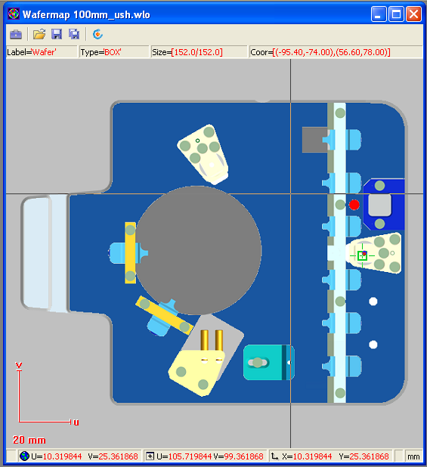
Figure 9: Wafer map in e-Line software.

- Turn the EHT target to the desired value (for example 10keV). See Figure 10. If the target is larger than 22kV, then set the target to 22kV first.
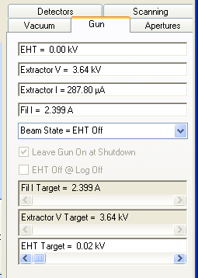
Figure 10: Gun tab.
- Turn on the electric high-tension (EHT) by left-clicking on ‘EHT’ at the lower right of the SmartSEM program and selecting ‘EHT On’. See Figure 11.

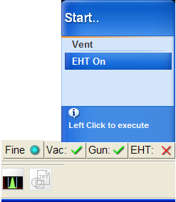
Figure 11: Starting up the EHT.

- Then turn up the EHT to the target acceleration voltage, if you wanted to go to voltages larger than 22kV. When you turn up the accelerating voltage, do it gradually towards the target. This is to prevent accidental sparks in the chamber.
- Change the detector signal to InLens as shown in figure 12. The InLens detector Works only for acceleration voltages -EHT- of less than 22kV. This is because the electrons are actually slowed down by about 8kV between InLens detector and final lens. The maximum voltage that the power supply can produce is 30kV, so that at 20kV EHT setting they are accelerated to 30keV and then slowed down to 22keV before reaching the sample. This way the secondary electrons produced in the sample are accelerated back into the column by those 8kV and hit the InLens detector (it is located inside the column) with 8keV. This results in a high signal-to-noise ratio. For higher voltages (>22kV) you can use the SE2 detector, which is located in the system chamber, viewing the sample at an angle.
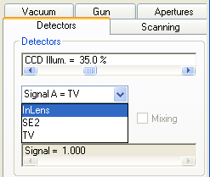
Figure 12: Detector tab.
- Make sure the beam is not blanked. There are two beam-blankers: one controlled by the Smart SEM software, the other by the Raith e-Line software. At this stage usually the e-line-software blanker is activated. Deactivate it by clicking the button in the icon bar (see figure 4).
- Zoom out all the way in the SmartSEM software. For example by clicking on Mag/Focus in the Apertures tab (see figure 13), then holding the left mouse button clicked inside the SEM image and moving the mouse to reduce the magnification. The current functions of the mouse buttons are always shown underneath the imaging area (see figure 14).
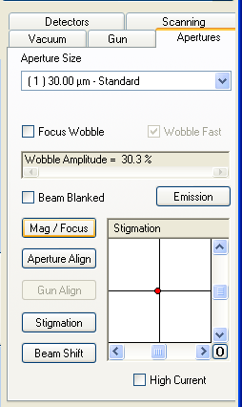
Figure 13: Apertures tab.
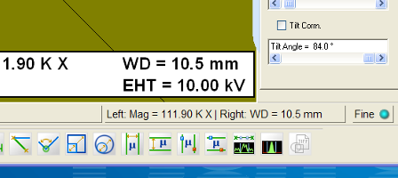
Figure 14: Mouse button configuration.

- Set the working distance to 10mm by double-clicking on WD (see figure 14) and entering 10 into the dialogue box. You should be able to see the scratched surface of the sample holder.
- Navigate to the edge of your sample and then find the corner of the sample where you deposited the polystyrene beads using the stage-joystick. Adjust the working distance clicking the right mouse button inside the imaging area (hold+move mouse left-right).
- The deposited beads should look like white stains. Increase the magnification and keep adjusting the working distance until you reach about 50kX magnification.
- Choose the aperture you want to use (30µm is standard) using the drop-down box in figure 13. You may want to choose a different aperture size to increase or decrease the beam current for your exposure.
- Next this aperture needs to be aligned (Especially when you have changed between apertures). Click on the check box focus wobble shown in figure 13. Move the reduced scan area so that it is centered on for example a single polystyrene bead. Then click on ‘Aperture Align’ button shown in figure 13. The position of the aperture can now be controlled using the scroll bars shown in figure 13. The aim is to minimize the left-right and up-down movement of the image during focus wobble. The horizontal scroll bar adjusts up-down movement and the vertical one adjusts left-right movement. Once the movement of the image is neutral de-select the focus-wobble checkbox.
- Adjust X and Y stigmation of the focus. The focus has not necessarily a circular shape. This shape can be adjusted using the stigmation controls. First reduce the scanning area (see figure 3) and center it on a polystyrene bead and use scan-speed-setting ‘4’ to get a low-noise image that is refreshed quickly. Click on the stigmation button shown in figure 13. Hold the left mouse button inside the imaging area and use alternate up-down and left-right movements of the mouse to find the optimal focus. It is best to always go from complete-defocus via good-focus to complete-defocus to really find the global optimal stigmation. If the stigmation or aperture alignment is far off you may not get a good image at 50k magnification. In that case you will have to do steps 16 and 17 first at a lower magnification.
- Readjust the working distance. You may need to check the aperture alignment again if the focus was far from optimal. But definitely do a few iterations of stigmation and working distance optimization until you get some contrast on the beads themselves when you zoom in to 100k magnification.
- Zooming in to about 300k magnification and taking a full image at scan speed setting 4 will reveal the vibrations of the system. Measure those and keep track of them between writes if you are interested in high resolution patterning.
- To further check the size and shape of your focus you can use the spot modus perhaps at 100k magnification. Navigate the center of your image (use cross hairs) to a clean resist surface patch. Click on the ‘Burn spot’ button in the icon bar of the SmartSEM software. This will stop the scanning and expose the sample at a single spot. The effect is that mostly some carbon both from the resist and the vacuum will deposit at that spot, revealing the stationary focus as a white contamination spot. If the spot is not visible you can right-click on the icon to turn spot modus on and off for an arbitrary amount of time (a few seconds should suffice). Then quickly take a scan speed 4 image of the automatically reduced scan area and stop the scanning (further scanning will deform the contamination spot). Now use the annotations below the imaging area to measure the size of the contamination spot. It should be circular and have a diameter of less than 30nm.
- Now the SEM column is set up for a high-resolution exposure. If you are just imaging your sample, you may not want to go through all of these focus adjustment steps with the same elaborateness and scrutiny. Also you may want to adjust the focus directly on the area of the sample you are trying to image, depending on how sensitive it is to the electron exposure. If there is a chance you want to use the image in a publication, be sure to optimize the focus elaborately - nothing turns a referee more off than bad SEM images!
- Getting a good image is not always straight forward. The first requirement is that your sample needs to be conducting. Isolating samples must therefore be coated with Gold-Palladium in the sputter coater or a thin aluminum film in the FC-2000. Next the conducting layer must have good contact with the sample holder. Introducing a thin metal foil between the sharp clip edge and your sample may help to contact thin metal layers on top of soft resist layers like PMMA. If your image is moving around a lot or changes contrast frequently it is a sign of charging. Do not expect good imaging results or exposure results. The only remedy is to unload your sample and try to do a better job at mounting it so that the electrons can flow away fast enough to not disturb the beam position.
- The InLens detector is not always the best choice for your images. At large working distances the SE2 detector works better. Furthermore, the SE2 detector gives better material contrast and can give a 3D impression since it looks at the sample at an angle. Also play with the Bias Voltage in the detector tab when using the SE2 detector. Sometimes the high energy back-scattered electrons carry the most information so that suppressing the low energy secondary electrons can reveal further detail and/or increase the 3D impression by casting clearer shadows.
- To save images first use the file menu in the SmartSEM software. (Save image as…). Select the image sub-directory in your user directory. Please do not save files anywhere else on the computer - otherwise they may be removed without notice. Choose a meaningful filestem and reset the numbering to 01. Clicking on the TIF icon will then save the images with increasing numbers in the filename, without having to go through the Save-as dialogue every time. Be sure to note details about location and sample either in the filename or in your notes! Images without clear description and record are scientifically just garbage.
Setup Raith e-Line software to perform e-beam exposure

UVW adjustment and beam current measurement:

- After successfully focusing the electron beam the next step should be to measure the beam current. This is done by directing the beam into a deep hole on the sample holder (Faraday cup) that absorbs the whole electron beam. The current between gun final lens and sample is then measured with the Keithley Piko-Amperemeter located in the rack. The read-out is done with the Raith e-Line software. To do this first save the current position with the beads on your sample by setting it as the new U,V coordinate origin. In the ‘Adjust UVW (Global)’ dialogue make sure that the U and V fields are at 0,0 and then click ‘Adjust’. This set the current stage position as the new origin.
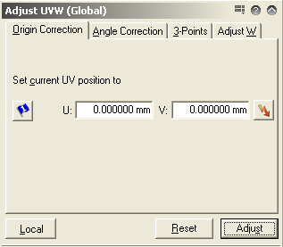
Figure 15: Origin correction.

- In the Stage control tab and the Positions sub-tab select ‘Faraday cup on holder’ and then click on ‘Go’. This drives the stage to the Faraday cup.
- In the SmartSEM software go back to the InLens/SE2 detector, zoom out, unblank the beam and center the black circular hole in the image using the cross hairs. Then zoom in to at least 10k.
- Back in the e-Line software go to the ‘Beam current’ tab in the dose lithography menu (5th lithography menu from the top in figure 4). Choose <current position> in the drop-down menu. Then click ‘Measure’. Repeat a few times to see if current is stable. It should not change more than by 0.1 pA. This measurement will be later used to calculate the dwell-time of the beam during the exposure.
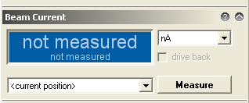
Figure 16: Beam Current measurement.

- Return the stage to the U,V=0,0 position for example using the ‘lightning’ button in the Adjust UVW tab (figure 15).
- At this stage you may want to align the U-axis with the horizontal edge of your wafer. This can facilitate finding structures on your sample. You can do this with a Angle Correction in the Adjust UVW tab (see figure 17). To do this, drive the stage to two points P1 and P2 along a horizontal edge of your sample. (The further apart they the more precise the alignment). At the left most point use the ‘pipette’ button below P1 to read in the first X,Y coordinates. At the right most point use the ‘pipette’ button below P2 to read in the second X,Y coordinates. A correction angle is thus calculated. If you press ‘Adjust’ it will correct the UV coordinate system, so that the U-axis is then parallel to the line connecting P1 and P2. To align with existing structures on your sample you can use the more advanced 3-point alignment (please refer to the manual). ‘Adjust W’ Can be used to correct the working distance at all places on your wafer, if its surface is not completely parallel with the XY plane (i.e. the sample is not in focus at all places with the same working distance setting). (Again, please refer to the manual for this.) Also note that there are two different UVW coordinate systems - global and local - for now just use the global one. Again, to learn how to use the local one, refer to the manual.
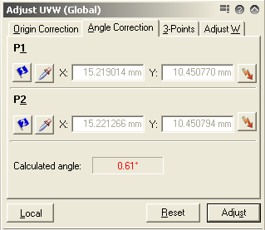
Figure 17: Angle Correction of UVW correction

Write-field alignment procedures

- In order for the beam deflection to be accurate enough for lithography applications (i.e. so that the pattern you write actually has the intended dimensions), the beam deflection needs to be calibrated. This is achieved with the align-write-field procedures which use the interferometric stage as a reference (1.5nm position accuracy). First open a new position list using the file menu (see figure 18).
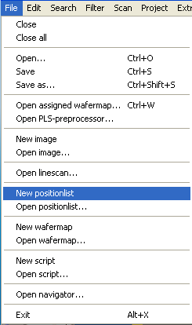
Figure 18: File menu of the Raith e-Line software.

- In the SmartSEM software center an artifact such as an accumulation of the polystyrene beads in the image using the stage-joystick and remember it as your reference point. The artifact should have distinguishable features even at low magnification of about 5k.
- Choose a 100 micrometer writefield in the patterning lithography menu (Don’t forget to click ‘activate’). You may want to use a different writefield size depending on your application. The 100 micron writefield can be accessed with the beam at a 2nm resolution. That means the pixels of the image you are going to draw into the resist will be 2nm spaced from each other. For other writefield-sizes the minimal step distance is determined by the 16bit address space in x and y deflection of the beam available in the pattern generator.
- In the Scan Manager (see figure 19) select ‘Writefield Alignment Procedures ->Manual‘. Drag ‚100 um WF - Manual ALWF 25 um marks‘ into the Position list.
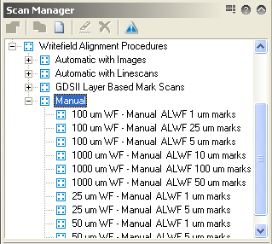
Figure 19: Manual align-writefield procedures.
- Right-click on the newly created entry in the position list and select ‚Scan‘
- In the images that pop up, find the artifact in the picture that you decided to use as a reference point. Hold ctrl and then also hold the left mouse button within the image and away from its center. A line between the center and your cursor is shown. Drag the cursor end of the line to your chosen reference point and let go of the left mouse button. Then click continue in the opened dialogue box. Depending on the settings in the procedure up to 8 reference images are taken, and based on these 8 error vectors a new transformation between XY and UV coordinates is calculated.
- At the end of the procedure the resulting transformation is displayed. Click accept as long as the corrections are not too big. Both zoom values should be close to 1, the shifts should be not much more than a few hundred nm, and the angles close to 0. If you have by mistake accepted a transformation that is completely wrong, it may send the stage to accordingly strange XY coordinates. This should be avoided. If it does happen simply reset the UVW transformation in the [Writefield alignment menu] and restart the alignment procedure from step 4.
- Repeat steps 4-7 for the ‘100 um WF…5 um marks’ and ‘100 um WF…1 um marks’ procedures.
- In the Scan Manager (see figure 20) select ‘Writefield Alignment Procedures ->Automatic with Images‘. Drag ‚100 um WF - Auto ALWF 5 um marks‘ into the Position list, as well as the ‚..1 um marks‘ one. Execute each in turn by selecting it in the position list and right-click on it + select ‚Scan‘. This procedure uses an automatic algorithm to determine the error vector that you have selected in the previous Manual procedures.
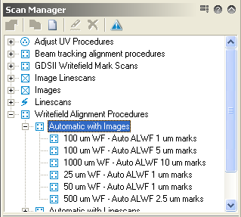
Figure 20: Automatic align-writefield procedures.
- In the Raith Protocol tool inspect the results from your alignment. (Choose the current date and write field alignments). You should see the transformation results from each of the alignment procedures. The values are relative, so that they should converge to 1 for the zoom and 0 for the shift and angles. The last digit of each of these relative transformations should be 3 or less for ideal alignment (i.e. to achieve the best stitching results and the best compliance of exposure with your pattern.)
- If the transformation did not converge as well as it should be you, could re-run the last Auto-alignment procedure. If the imaging contrast on your sample is very bad, you may have to redefine the procedures with higher point averaging for example to get better imaging or perhaps use frame averaging so that the sample does not charge as much during the imaging (and thus deflect the beam in random directions). You can duplicate the procedures in the scan manager, save them under a different name and then edit them.
- If you do use the fixed-beam moving-stage mode in your patterns, you also have to perform Beam-tracking alignment, which is very similar to the writefield alignment procedures. If you do not use the FBMS jump to step 15. The corresponding procedures are stored in the scan manager under ‘Beam tracking alignment procedures’ - see figures 21 and 22. With these procedures the electronics deflecting the beam during a fixed-beam moving-stage exposure are calibrated (The beam is not completely fixed but corrects errors of the stage movement - otherwise it would be very difficult to expose sharp corners for example).
- As with the write field alignment drag the Manual 10um, 5um and 1um procedures and execute them using the position list. Again input the error vectors using the same reference point as before during writefield alignment.
- As with the write field alignment drag the Automatic with Images ‘5 um marks’ and ‘1um marks’ procedures and execute them using the position list
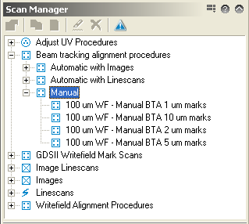
Figure 21: Manual beam tracking alignment procedures.
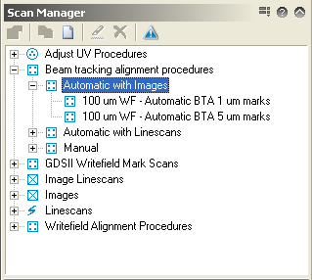
Figure 22: Automatic beam tracking alignment procedures.

- Now the writefield is aligned with your sample.

Loading your pattern file

- In the patterning menu (1st lithography menu from the top in figure 4) you can load an existing pattern library (GDSII database file). The program supports many different formats. Please consult the manual for the different possibilities for importing your pattern. The pattern can also be generated using the e-Line software. Just create a new library file (.csf file), using the white sheet icon at the top left (see figure 23). Then right click into the white space underneath the menu, then select [‘new pattern’ ]. Select the new structure entry and the click on edit to open the GDSII editor. At the top right hand corner you will find the icon that opens the toolbox window which gives access to a large number of functions to create your pattern from scratch, or edit it. Check the manual for details.
- If you have created your pattern ascii text file using another programming tool like Matlab, the import dialogue is somewhat hidden. Select the menu button marked in figure 23 and choose ‘Load Ascii…’ to import the pattern text file.
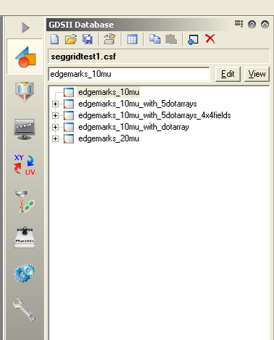
Figure 23: Pattern Database editor.

Calculating dwell-time

- In the patterning menu (see fig 24) choose the kind of patterning elements you are using in your patterning file and then click on the calculator icon.

Figure 24: Getting to the patterning calculator.
- In the calculation window check that the beam current measured earlier appears in the beam current field (see figure 25). Then choose an area step size (20nm to get you started, 2nm is minimum for the 100 micron writefield) and an area dose (100 µC/cm^2 is a good start for at 10keV and a thin PMMA layer). Click on the calculator icon next to the Area Dwell time field, which calculates the correct dwell time for the chosen parameters, so that the equation displayed at the bottom of the window is satisfied and the ‘Areas’ heading turns from red to black. Perform the same actions for the other element types (curved elements, lines, etc) depending on which ones you use in your pattern file. For details check the Software Operation Manual.
- Click Ok once you have convinced yourself that all parameters are correct.

Figure 25: Pattern Parameter Calculator.

Starting the exposure

- Make a new position list using the Raith e-Line software file menu
- From the GDSII database drag a structure into the position list.
- Choose the correct U,V position of your pattern. The U,V coordinates here refer to the center of the bottom left writefield in your pattern. Double click on the position list entry to see how the software divided your pattern into writefields.
- By right-clicking on the position list entry and selecting ‘Properties’ you can choose various exposure properties - see figure 26. Most importantly you can click on ‘Times’ which will calculate an estimate for the time it takes to expose your pattern. Note this down so that you will know when to come back to unload your sample.
Figure 26: Patterning properties.

- Choose the Layers of your pattern that you want to expose using the layer button shown in figure 26.
- If you are not sure about the dose to use, the first thing should be to write a dose matrix. For this set the dose factor in the position list entry to 0.5. Then choose ‘Matrix Copy’ in the Filter Menu. Configure a 3x3 matrix and choose the dose factor to increase by adding 0.2 for each matrix element. Make sure you appropriately space and position the matrix elements. You should never have to write a pattern that is larger than a single writefield to do this - choose only a small subset of your pattern (using the GDSII pattern editor) to perform this exposure experiment.
- In the Automation menu also drag the ‘ShutDownbeam.js’ procedure at the end of the position list. This will shut down the EHT at the end of your exposure.
- Change the U,V position of this last position list entry to a location that is away from your sample so that it is no longer exposed by any stray electrons that may make it past the beam blanker. This will cause the stage to drive to these UV coordinates at the end of the exposure.
- Select all the position list entries using CTRL or SHIFT + left click. Then right-click on the selected entries and select ‘Scan’. This starts the exposure.
- You can check if the exposure is successfully on the way, but looking at the beam deflection LEDs in the electronics rack.
- Unless the write is very quick, you can now turn the screens off, as well as turning the mouse off. You should post to the eline calendar how long approximately the write will take.

Unloading your sample via the load-lock

- Before you unload the sample, make sure that there is a sample holder inside the sample holder. This can be done by checking the infrared camera (TV-detector) inside the e-line.
- To initiate the unload procedure, go to the "Sample loading" screen:

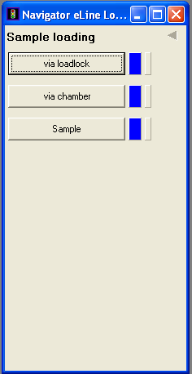

- Select "via loadlock" and then "Load Sample". Confirm the dialogue asking you if you wish to proceed. After this you will need to follow the instructions carefully:

- Check that the load-lock is fully closed with the load-lock door-knob (see figure 6). Click ok.

- When you open the loadlock valve, make sure it’s pulled all the way out. The transfer rod should be inserted steadily and carefully all the way in. Click ok, and wait for the following info box to appear:

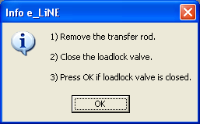

- Pull out the transfer rod steadily and make sure that the loadlock valve is shut.
- Loosen the load-lock door-knob, to make sure the load-lock door does not get stuck when it is filled with up to 0.3 bar overpressure.
- Click ok, and wait for the Load-lock to vent to atmospheric pressure. You can open the load-lock door once the pressure has equalized (it is easy to open it then - never force the door open!). When the proces is complete a confirmation will be displayed.
- Remove your sample from the sample holder and put the sample holder back into the load-lock, closing it afterwards.
- Log out of the Raith E-Line software, perhaps saving your position list that you used for the exposure first.
- If the EHT is not already shutdown, do that now.
- Set the detector to InLens mode, to not keep the infrared camera running.
- Turn off both screens, the mouse and also switch off the stage-joystick (by pressing the X and Y buttons).

Developing your sample

- Take your sample in a Fluoroware container to the cleanroom in room 268. Observe the current clothes requirements for the cleanroom (at least wear a lab coat, protective glasses, latex gloves, and hood)
- Develop the sample by dipping it into the provided Allresist developer for 2 minutes. (You can of course adapt this development time, if you want to use different dosage parameters etc)
- If exact line widths are very important for your process it will be important to control the temperature of your developer for example using a hotplate or by warming it with your hands to about 21°C.
- Stop the development by rinsing your sample with Isopropanol for about 20 seconds. Alternatively you can also dip your sample in the provided Allresist stopper.
- Solvent clean all glass ware before and after the development process to be sure to avoid particle contamination.

Examining your exposure

- An optical microscope (not available yet inside the cleanroom) may be enough to do a first quick step if the exposure worked, depending on the size of your patterns.
- To evaluate a dose matrix reload the sample into the e-Line after coating it with the sputter coater. Find the exposure in your matrix that best fits with the dimensions given in your pattern file, and also make sure that there is not resist left in completely exposed areas (sign of underexposure). Note that PMMA works as negative resist at high doses (The PMMA molecules are cross linked instead of split), so at the high doses of your matrix you may see an inversion of your pattern. Note the dose that corresponds to the best result, and use it from then on to write your patterns. If you keep development, your sample type and the pattern the same it should not be necessary to write multiple dosages anymore.
- In order to examine the sidewall of your exposure you have to write large enough pattern areas so that it is possible to cleave the wafer through the exposed pattern. The cleaved edge can then be mounted in the 45° mount on the sample holder and thus the side walls become visible in the SEM images. To some extend this can be achieved using the SE2 detector (since it also looks at the sample at an angle), but cleaving is the preferable option.
- Sometimes the exposure fails because the Raith E-Line software does not manage to interpret your pattern file correctly. So take utmost care to keep you pattern files simple and obvious for the e-Line software to interpret.

Document History

Version 0.1, 26 JAN-2012, Author: Thomas Myking Bolstad, Changes: First procedure with screenshots
Version 0.2, 27 FEB-2012, Author: Thomas Reisinger, Changes: Added overview of steps, reworked procedure details

