UiB Nanostructures Laboratory
Standard Operating Procedure
Precision Spin Coater Model KW-4A

Purpose of the instrument:
The Precision Spin Coater Model KW-4A is used applying layers of resist onto wafers used for electron beam lithography or photolithography.
Location of the instrument:
Allégaten 55, room 286 (entrance via room 276, E-Beam lithography Lab)
Primary Staff Contacts:
Erik Mannseth (Tel: 555-88326, Mob: 91626999, E-mail: Erik.Mannseth@ift.uib.no)
Thomas Reisinger (Tel: 555-88326, Mob: 94784857, E-mail: thomas.reisinger@ift.uib.no)
Xiaodong Guo (Tel: 555-88327, Mob:, E-mail: Xiaodong.Guo@ift.uib.no)
Bodil Holst (Tel: 555-82967, Mob:, E-mail: Bodil.Holst@ift.uib.no)
Service Contacts:
Available source materials:
PMMA ( Poly(methyl methacrylate) ) e-beam resist, Ar-p 3540 (2- methoxy-1-methylethylacetate) Photoresist

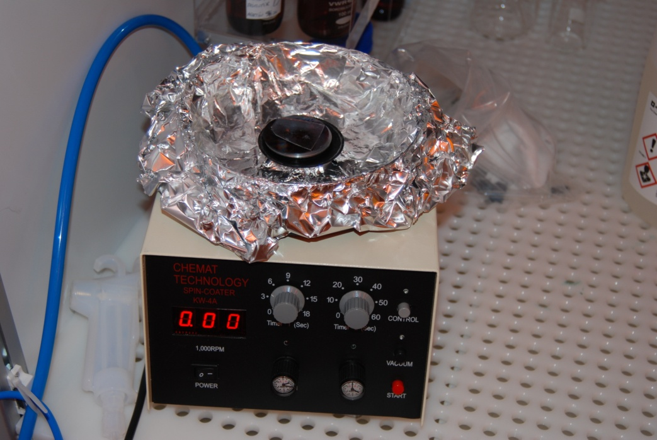
Figure 1: The spin coater tool: Buttons on the right are from top to bottom: Control (lets you start the tool), Vacuum (turns on the vacuum), and start (starts the spin process). On The lower left is the power button. The four knobs in the middle are from top left going right and down, timer for the slow spin speeds (up to 2500 RPM), timer for the fast spin speeds (up to 8000 RPM), speed setting for the slow spin speeds and speed setting for the fast spin speeds.
WARNINGS
- Do not touch or hold the shaft or chuck while rotating. Severe injury may result.
- Substrate may fly off rotating chuck. Precautions should be taken to protect operator and others from injury while operating spin coater equipment.
- Dangerous electrical potentials are present inside-the cabinet. Be sure to unplug the line cord before opening the cabinet.
- Motor brushes and switch contacts may produces electrical sparks. Do not use the laboratory spinner in the presence of any explosive atmosphere.
- Early termination of preset cycle may result in machine reverting to maximum revolutions when restarting. Please shut off machine before resetting.
Make sure to put on the lid on the spin coater before running the spin cycle to avoid spilling of the materials.
The UiB NanoStructures Lab is operated for the benefit of all researchers. YOU MUST HAVE RECEIVED PERSONAL TRAINING ON THE INSTRUMENT TO BE PERMITTED TO OPERATE IT! IF YOU HAVE BEEN TRAINED AND ARE STILL UNCERTAIN AS TO HOW TO OPERATE THE INSTRUMENT CONTACT ONE OF THE STAFF MEMBERS. If you encounter any problems with this piece of equipment, please contact the staff member listed above immediately. There is never a penalty for asking questions. If the equipment is not behaving exactly the way it should, contact a staff member. This SOP only serves as a quick reference. For further details consult the manual and/or service engineers.
Basic Usage

Figure 1 shows the tool.

- Place the wafer onto the holder in the center of the spin coater.
- Turn on the compressor pump for the vacuum.
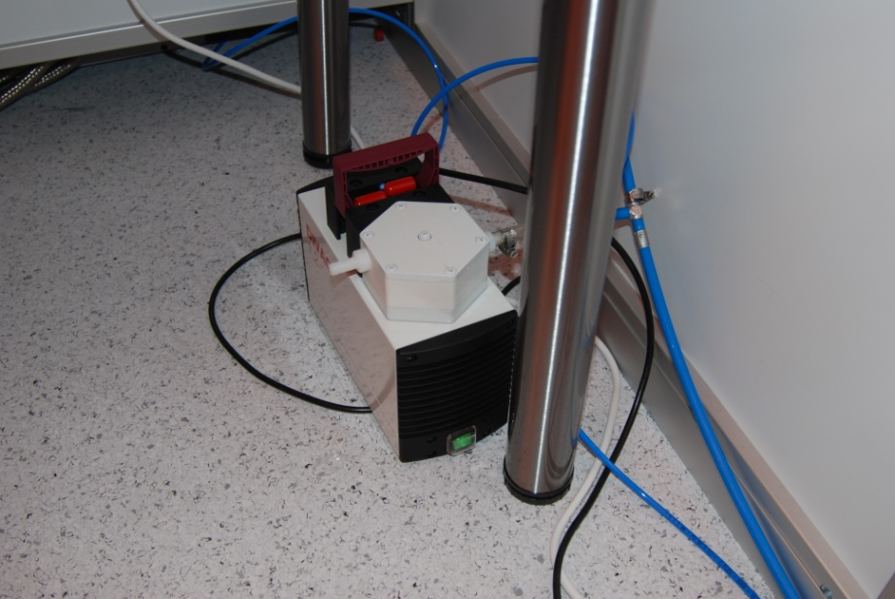
- Turn on the hotplate to the wanted temperature for use later (it needs time to heat up). For PMMA the temperature is 175°C.
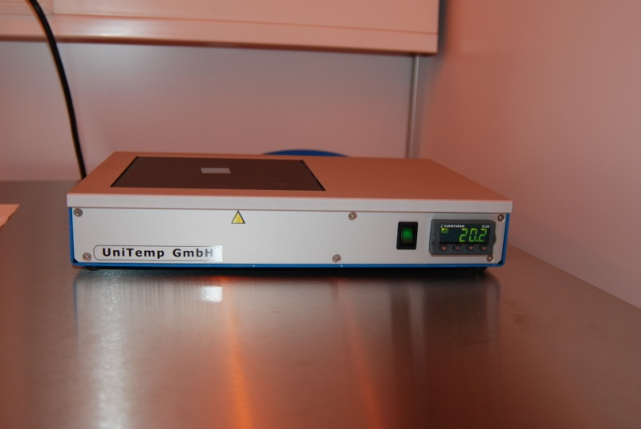
- Press the vacuum button on the spinning tool. Make sure the wafer is actually stuck to the holder by the vacuum.
- Set the wanted spin speed using the two knobs on the front. The one on the left adjust spin up speed and the one on the right is the speed which determines the thickness of the layer. You can also adjust the time each of these should spin, using the knobs above the speed adjusters, but that will not usually be necessary (see Figure 2 for an image of the control panel).
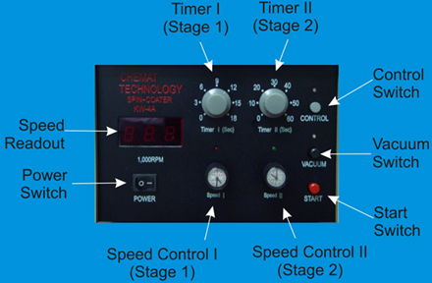
Figure 2: Image of the control panel
- Drip enough (a circle of about 1/3 the size of the wafer) of the material you are spinning onto the center of the wafer, using a clean pipette. Avoid making bubbles in the liquid (if a bubble appears you can try to remove it by suctioning it up using the pipette). A clean pipette is one that has been solvent cleaned in the fume hood (using acetone, methanol and isopropanol).
- When this is done press the control button (this has to be pressed to be allowed start the spinning), and press start.
- After the spin coater reaches its maximum speed you can take the lid of and watch the process. The color of the layer will change, this is an indicator of the thickness of the layer, when the color is even across the wafer it is evenly distributed. AFTER the spinning stops and you want to remove the wafer press the vacuum button, so the wafer is no longer stuck to the holder.
- When the wafer is finished spinning it needs to be baked to harden the resist. This is done at the hotplate which was turned on earlier. Place the wafer at the center where there is a hole connected to the pump, the wafer should be stuck to the hotplate by this hole.
- After the wafer has baked for the given amount of time (common time for PMMA is 90 seconds) remove the wafer from the hotplate and turn the hotplate off. The wafer is now ready to be cut, used or set aside for later. Wafers should be stored in fluoroware containers to avoid contamination from dust or other damaging factors.
- Document History

Version 0.1, Feb-2012, Author: Erik Mannseth

